### PRC-25 Radio Gear

The major field radio of the Vietnam War was the AN/PRC-25. "AN" meant it was a piece of military electronics, not a truck or a weapon or a can of SPAM. "PRC" meant it was a portable radio, "-25" meant it was the 25th one the military had standardized. It was inevitably referred to as a "Prick Twenty-Five" by GIs, or "Prick" for short. The PRC-25 was about the size and weight of a case of soda. With its battery "can" included, call it a case of soda sitting on top of a six-pack. (It actually weighed slightly more than that, 23.5 pounds) There was a handle on each side at the top to carry it. The radio consisted of two parts, both in metal boxes, called "cans." The upper can held the radio itself, the lower can held its battery pack. Metal buckles held the two together. The radio was tough and would easily survive a 50 foot fall from a helicopter onto a metal-planked runway. You could throw the whole thing in the water for an hour, completely submerged, then pull it out and expect it to work. It could be battery powered for use as a backpack radio, or it could be plugged into an external power source for use in a vehicle or a helicopter.

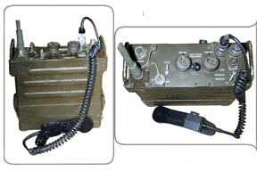

Set up for use in a vehicle or aircraft, the PRC-25 looked like this.

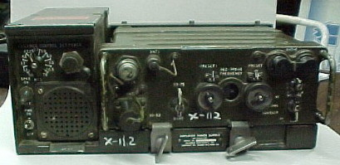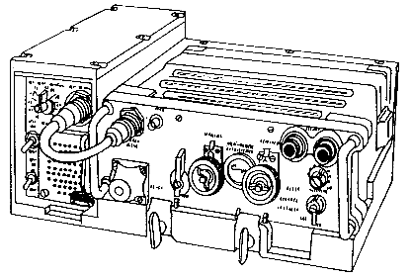

The extra box included a speaker and a conversion to the vehicle/aircraft's electrical system.

The operator controls were on top and looked like this:

The two "pre-sets" were done at the base camp. Usually they would be tuned to a selected main frequency and an alternative. The FUNCTION switch, in order, turned ON the radio, then SQUELCH suppressed static. RETRANS was a mode that allowed it to act as a relay for another radio. LITE turned on the little light in the REC-TRANS FREQUENCY channel dial, for night work. The VOLUME control controlled the receive volume. The PRC-25 worked like a car radio, you could dial in any frequency at any time, preset any two, then use the switches to select either of them, usually called a "push." And maybe then dial in and use a third. The radio was issued with its own pack frame.

The radio's weak point was the communications handset. The handset was like a telephone handset, with a "push to talk" bar. A hook on the back allowed you to hang the handset off your web gear, etc. The handset could simply not get wet. In a wet, humid, country like Vietnam, this was a serious problem. The usual way to deal with this was to put the handset inside the clear plastic bag (usually the one from the radio battery's packaging), tie it in place with a rubber band, and use it like that. Fording streams, the handset had to be held clear of the water. For all that, the microphone was fairly sensitive and could even be whispered into.

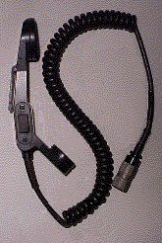

The radio antenna was exactly like a metal tape measure, but the bottom foot or so was a round flexible tube that screwed into the radio. There were actually two antennas, a regular one and a long-range antenna, carried in a canvas bag strapped to the side of the radio The radio had a transmission range, with the short antenna, of about 3-4 miles, but various terrain factors could influence this, of course. It helped to be higher up. The long range antenna was supposed to be good for up to 18 miles.

The rule of thumb was that the battery was good for about a day of casual operation, listening mostly, some occasional transmissions. In a period of intense use, transmitting/receiving all the time, it was good for perhaps 2-3 hours. The way the LRRPs and SF used it, shutting it off and only coming up at scheduled times to briefly transmit or listen, it was good for perhaps four days. Spare batteries were usually kept in a spare .30 caliber ammo can. When expended, the battery pack had to be physically destroyed. Inside were flashlight-type batteries which the Viet Cong could use in booby traps or to ignite bombardment rockets.

The RTO (Radio/Telephone Operator) was usually carefully chosen. He had to be someone with experience, who wouldn't get rattled under fire. He had to be able to read maps, too. If something happened to the officer, the RTO would effectively command the unit, calling in fires, getting in medevacs, etc. It was also a dangerous job, since the radio antenna said to the enemy "Shoot ME first!" But an experienced RTO became like a "private secretary" to the officer, anticipating what might be wanted and preparing it in advance. At night, he and the officer, the platoon sergeant, and platoon medic slept close together, alternating radio watch, the "Twenty-Five" within reach of all. RTOs within a unit got to know each other too, and formed a kind of bond, since they did all the communications. There was a "status" to being the RTO. All the RTOs administratively reported back to the communications section back at battalion. The commo section also maintained your radio for you, out of the field.